**Arrays in Javascript Vs Arrays in C++**

In JS arrays are not pure arrays rather they are objects.

Also by default the arrays in javascript are of dynamic nature.

A dynamic array is an array which can grow itself as we go on adding items in it.

**What is garbage collection in javascript?**

The low-level programming languages like c++ provides memory management primitives such as new and delete, where the users themselves free the used memory.

Now the high-level languages like JavaScript allocates memory when things (objects, strings, etc.) are created and “automatically” frees it up when they are not used anymore, a process called garbage collection.

Some high-level languages, such as JavaScript, utilize a form of **automatic memory management** known as garbage collection (GC). The purpose of a garbage collector is to monitor memory allocation and determine when a block of allocated memory is no longer needed and reclaim it.

In javascript When an object is no longer used, the garbage collector **reclaims the underlying memory and reuses it for future object allocation**.

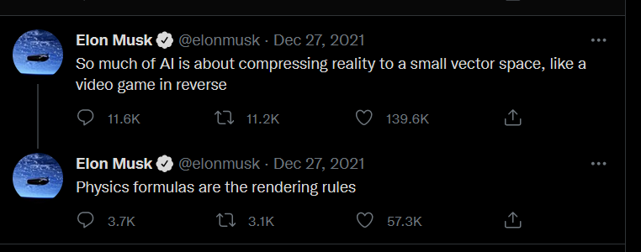

There are mainly two types of databases

1. Relational databases
2. Non relational databases

Now the real world data themselves may be

either

1. Relational

or

1. Non relational

So let say learning only one type of databases and trying to use that database for both type of real world data sounds kind of akward and not good